ABSTRACT

This Result analysis project enables us to analyze the performance of the student by taking students marks into consideration. Unlike giving percentages to the student in present system here we assign grades to each student according marks secured by him in grading system. This application will automatically generates the reports that contain information like total marks obtained by student, marks obtained each subject, grades obtained by students, SGPA (semester grade point average) obtained in particular semester, CGPA (cumulative grade point average) for cumulative semester and we can know in which subject student passed and in which subject student failed.
This application generates three kinds of reports to analyze performance of student. They are
- Semester wise – this report contains marks obtained in particular semester along with SGPA. Through this we can analyze the performance of student in semester wise.
- Cumulative semester wise – this report contains marks obtained by student from the starting of the academic year to present semester. And it also generate CGPA along with SGPA in each semester.
- Branch wise – this report is useful for analyzing performance of student in each subject i.e we can know how many students get passed and how many students get failed in each subject.

1. INTRODUCTION

1. INTRODUCTION

1.1 ABOUT THE PROJECT
Result analysis system is a web application that generates reports in tabular form depending on the information provided by the user and it uses data that is stored in database. Here student marks sheet is directly uploaded into the database.

A college Result analysis system is for coordinating these four elements:
- students
- lecturers
- marks
- Grades (SGPA,CGPA)

Colleges are supposed to analyze the performance of student for each semester which is a very tedious and pain staking job. One of the major drawbacks of the existing system is that a lot of time is consumed as the time table is prepared manually. A lot of paper work is also involved. Finding substitutes for the absenting lecturers is also very difficult.

Our project is aimed at developing technologically superior software that manages the timetable of a College/Institute.

1.2 PURPOSE

This web application is useful for analyzing the performance of student in their exams in terms of grades rather than percentages. This application takes the marks of student as input and generates the different kinds of reports according to the requirements of user. This report contains information like grade obtained by student, sgpa and cgpa etc.

2. SYSTEM ANALYSIS

2. SYSTEM ANALYSIS

2.1. INTRODUCTION
In our present system we assign grades to each student instead of percentage. Grades are categorized into A,B,C,D etc. similar to the traditional system, here also student has to reach minimum marks in each subject in order to get through the exam. We calculate SGPA(semester grade point average) for each student in each semester and based on the SGPA value we categorize the student. We also calculate CGPA(cumulative grade point average).
Here in our existing system we generate different kinds of reports according to user need. And manual work of entering the marks of student into database is also reduced as we directly upload the marks sheet into database. If user wants performance of student in terms of percentage, it is also possible.
2.2. ANALYSIS MODEL
The model that is basically being followed is the WATER FALL MODEL, which states that the phases are organized in a linear order. First of all the feasibility study is done. Once that part is over the requirement analysis and project planning begins. If system exists one and modification and addition of new module is needed, analysis of present system can be used as basic model.

The design starts after the requirement analysis is complete and the coding begins after the design is complete. Once the programming is completed, the testing is done. In this model the sequence of activities performed in a software development project are: -
- Requirement Analysis
- Project Planning
- System design
- Detail design
- Coding
- Unit testing
- System integration & testing

Here the linear ordering of these activities is critical. End of the phase and the output of one phase is the input of other phase. The output of each phase is to be consistent with the overall requirement of the system. Some of the qualities of spiral model are also incorporated like after the people concerned with the project review completion of each of the phase the work done.
WATER FALL MODEL was being chosen because all requirements were known beforehand and the objective of our software development is the computerization/automation of an already existing manual working system.

Communicated Requirements

Requirements Specification

Design Specification

Executable Software Modules

Integrated Software Product

Delivered Software Product

Changed Requirements

Requirements Engineering
Design
Programming
Integration
Delivery
Maintenance

Product
Product

input

output

Process

Fig 2.1: Water Fall Model

2.3. STUDY OF THE SYSTEM

The problem under consideration is to automate the process of analyzing the student performance in an educational institution subjected to the given constraints. The user will specify the constraints and these constraints will drive to analyze the performance of student. The user may specify some of the following constraints.
- The number of departments in his institution.
- The number of staff personnel available in each department.
- The number of classes in each department.
- The number of subjects to be dealt for each class.
- The number of students marks to be uploaded in database.

2.3.1 MODULES IN THE PROJECT:

The system after careful analysis has been identified to be presented with the following four modules:
- Database creation Module

- Front-end design Module

- Report generation Module

- System Administrator Module
2.3.2 Entities Involved in the Project:
The following major entities have been identified in this system.

- LECTURER
- STUDENT

2.3.2.1 LECTURER Entity:

It models the real world teacher object by specifying his attributes such as name, identification number and it also describes the information regarding the maximum number of hours he can handle per week and his priority.
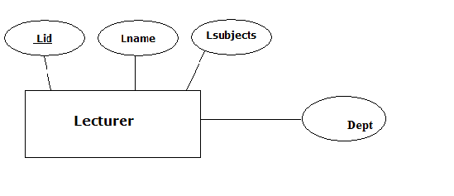
Fig 2.2: lecturer entity diagram

STUDENT Entity:

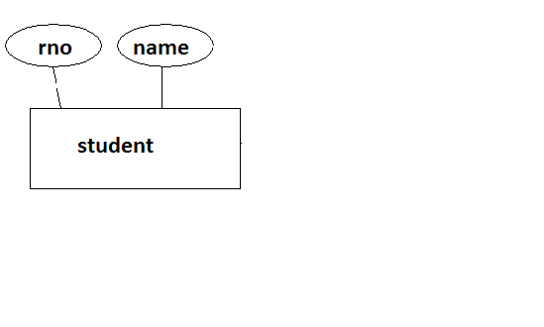

Fig 2.3: student entity diagram

2.4. EXISTING SYSTEM-PROPOSED SYSTEM

In present education system we validate the performance of student in terms of percentage i.e. we consider marks secured by him and we will calculate the equivalent percentage. We categorize the students based on the percentage they got(Ex: if student secures above 70 percentage then he/she falls under the category of distinction). And we will propose minimum pass marks in each subject, student has to get minimum marks in each subject, if he/she doesn’t get minimum marks then they considered as fail in exam.

2.4.1 Advantage of the proposed system:

- Marks can be directly uploaded into the database which reduces time and manual work.
- Results are analyzed based on both percentages and grades.
- Different kinds of reports are generated based on client requests.
- Unlike giving percentages to the student in present system , here we assign grades to each student according marks secured by him in grading system . This grading system is implemented by many autonomous institutes like IIT’s.
- Here we generate reports of a student along with grades , SGPA and CGPA.

2.5 HARDWARE AND SOFTWARE SPECIFICATIONS

2.5.1 HARDWARE REQUIREMENTS:

- PIV 2.8 GHz Processor and Above (Personal Computer).
- RAM 512MB and Above (Personal Computer).
- HDD 20 GB Hard Disk Space and Above (Personal Computer).

2.5.2 SOFTWARE REQUIREMENTS:

- WINDOWS OS (XP / 2000 / 2003 Server / Vista)
- Eclipse Galileo
- JAVA/J2EE
- Microsoft Access Database
- Apache Tomcat 5.5

3. Feasibility Report

3. Feasibility Report
3.1. INTRODUCTION
Preliminary investigation examine project feasibility, the likelihood the system will be useful to the organization. The main objective of the feasibility study is to test the Technical, Operational and Economical feasibility for adding new modules and debugging old running system. All system is feasible if they are unlimited resources and infinite time. There are aspects in the feasibility study portion of the preliminary investigation:
- Technical Feasibility
- Operation Feasibility
- Economical Feasibility

3.2. Technical Feasibility
The technical issue usually raised during the feasibility stage of the investigation includes the following:
- Does the necessary technology exist to do what is suggested?
- Do the proposed equipments have the technical capacity to hold the data required to use the new system?
- Will the proposed system provide adequate response to inquiries, regardless of the number or location of users?
- Can the system be upgraded if developed?
- Are there technical guarantees of accuracy, reliability, ease of access and data security?

Earlier no system existed to cater to the needs of ‘Secure Infrastructure Implementation System’. The current system developed is technically feasible. Thus it provides an easy access to the users. The database’s purpose is to create, establish and maintain a workflow among various entities in order to facilitate all concerned users in their various capacities or roles. Permission to the users would be granted based on the roles specified. Therefore, it provides the technical guarantee of accuracy, reliability and security. The software and hardware requirements for the development of this project are not many and are already available in-house at NIC or are available as free as open source. The work for the project is done with the current equipment and existing software technology.

3.3. Operational Feasibility
Proposed projects are beneficial only if they can be turned out into information system. That will meet the organization’s operating requirements. Operational feasibility aspects of the project are to be taken as an important part of the project implementation. Some of the important issues raised are to test the operational feasibility of a project includes the following: -
- Is there sufficient support for the management from the users?
- Will the system be used and work properly if it is being developed and implemented?
- Will there be any resistance from the user that will undermine the possible application benefits?

This system is targeted to be in accordance with the above-mentioned issues. Beforehand, the management issues and user requirements have been taken into consideration. So there is no question of resistance from the users that can undermine the possible application benefits.
The well-planned design would ensure the optimal utilization of the computer resources and would help in the improvement of performance status.

3.4. Economic Feasibility
A system can be developed technically and that will be used if installed must still be a good investment for the organization. In the economical feasibility, the development cost in creating the system is evaluated against the ultimate benefit derived from the new systems. Financial benefits must equal or exceed the costs.
The system is economically feasible. It does not require any addition hardware or software. Since the interface for this system is developed using the existing resources and technologies available. There is nominal expenditure and economical feasibility for certain.

4. SOFTWARE REQUIREMENT SPECIFICATION

4.1 INTRODUCTION

Purpose: The main purpose for preparing this document is to give a general insight into the analysis and requirements of the existing system or situation and for determining the operating characteristics of the system.

Scope: This Document plays a vital role in the development life cycle (SDLC) and it describes the complete requirement of the system. It is meant for use by the developers and will be the basic during testing phase. Any changes made to the requirements in the future will have to go through formal change approval process.

4.2 DEVELOPERS RESPONSIBILITIES OVERVIEW:

The developer is responsible for:

- Developing the system, which meets the SRS and solving all the requirements of the system?
- Demonstrating the system and installing the system at client's location after the acceptance testing is successful.
- Submitting the required user manual describing the system interfaces to work on it and also the documents of the system.
- Conducting any user training that might be needed for using the system.
- Maintaining the system for a period of one year after installation.

4.3. FUNCTIONAL REQUIREMENTS:

OUTPUT DESIGN

Outputs from computer systems are required primarily to communicate the results of processing to users. They are also used to provide a permanent copy of the results for later consultation. The various types of outputs in general are:
- External Outputs, whose destination is outside the organization.
- Internal Outputs whose destination is with in organization and they are the
- User’s main interface with the computer.
- Operational outputs whose use is purely with in the computer department.
- Interface outputs, which involve the user in communicating directly.

4.3.1 OUTPUT DEFINITION

The outputs should be defined in terms of the following points:

- Type of the output
- Content of the output
- Format of the output
- Location of the output
- Sequence of the output

It is not always desirable to print or display data as it is held on a computer. It should be decided as which form of the output is the most suitable.

For Example
- Will decimal points need to be inserted
- Should leading zeros be suppressed.

4.3.2 Output Media:
In the next stage it is to be decided that which medium is the most appropriate for the output. The main considerations when deciding about the output media are:
- The suitability for the device to the particular application.
- The need for a hard copy.
- The response time required.
- The location of the users
- The software and hardware available.
Keeping in view the above description the project is to have outputs mainly coming under the category of internal outputs. The main outputs desired according to the requirement specification are:
The outputs were needed to be generated as a hot copy and as well as queries to be viewed on the screen. Keeping in view these outputs, the format for the output is taken from the outputs, which are currently being obtained after manual processing. The standard printer is to be used as output media for hard copies.

4.4 INPUT DESIGN

Input design is a part of overall system design. The main objective during the input design is as given below:

- To produce a cost-effective method of input.
- To achieve the highest possible level of accuracy.
- To ensure that the input is acceptable and understood by the user.

4.4.1 INPUT STAGES:
The main input stages can be listed as below:

- Data recording
- Data transcription
- Data conversion
- Data verification
- Data control
- Data transmission
- Data validation
- Data correction

4.4.2 INPUT TYPES:
It is necessary to determine the various types of inputs. Inputs can be categorized as follows:
- External inputs, which are prime inputs for the system.
- Internal inputs, which are user communications with the system.
- Operational, which are computer department’s communications to the system?
- Interactive, which are inputs entered during a dialogue.

4.4.3 INPUT MEDIA:
At this stage choice has to be made about the input media. To conclude about the input media consideration has to be given to;
- Type of input
- Flexibility of format
- Speed
- Accuracy
- Verification methods
- Rejection rates
- Ease of correction
- Storage and handling requirements
- Security
- Easy to use
- Portability

Keeping in view the above description of the input types and input media, it can be said that most of the inputs are of the form of internal and interactive. As input data is to be the directly keyed in by the user, the keyboard can be considered to be the most suitable input device.

4.5 ERROR AVOIDANCE
At this stage care is to be taken to ensure that input data remains accurate form the stage at which it is recorded up to the stage in which the data is accepted by the system. This can be achieved only by means of careful control each time the data is handled.

4.6 ERROR DETECTION
Even though every effort is make to avoid the occurrence of errors, still a small proportion of errors is always likely to occur, these types of errors can be discovered by using validations to check the input data.
4.7 DATA VALIDATION
Procedures are designed to detect errors in data at a lower level of detail. Data validations have been included in the system in almost every area where there is a possibility for the user to commit errors. The system will not accept invalid data. Whenever an invalid data is keyed in, the system immediately prompts the user and the user has to again key in the data and the system will accept the data only if the data is correct. Validations have been included where necessary.
The system is designed to be a user friendly one. In other words the system has been designed to communicate effectively with the user. The system has been designed with pop up menus.

4.8 USER INTERFACE DESIGN
It is essential to consult the system users and discuss their needs while designing the user interface:

4.8.1 USER INTERFACE SYSTEMS CAN BE BROADLY CLASIFIED AS:
- User initiated interface the user is in charge, controlling the progress of the user/computer dialogue. In the computer-initiated interface, the computer selects the next stage in the interaction.
- Computer initiated interfaces

In the computer initiated interfaces the computer guides the progress of the user/computer dialogue. Information is displayed and the user response of the computer takes action or displays further information.

4.8.2 USER_INITIATED INTERFACES
User initiated interfaces fall into tow approximate classes:
- Command driven interfaces: In this type of interface the user inputs commands or queries which are interpreted by the computer.
- Forms oriented interface: The user calls up an image of the form to his/her screen and fills in the form. The forms oriented interface is chosen because it is the best choice.

4.8.3 COMPUTER-INITIATED INTERFACES
The following computer – initiated interfaces were used:
- The menu system for the user is presented with a list of alternatives and the user chooses one; of alternatives.
- Questions – answer type dialog system where the computer asks question and takes action based on the basis of the users reply.

Right from the start the system is going to be menu driven, the opening menu displays the available options. Choosing one option gives another popup menu with more options. In this way every option leads the users to data entry form where the user can key in the data.

4.9 ERROR MESSAGE DESIGN:
The design of error messages is an important part of the user interface design. As user is bound to commit some errors or other while designing a system the system should be designed to be helpful by providing the user with information regarding the error he/she has committed.

This application must be able to produce output at different modules for different inputs.

4.10. PERFORMANCE REQUIREMENTS

Performance is measured in terms of the output provided by the application.

Requirement specification plays an important part in the analysis of a system. Only when the requirement specifications are properly given, it is possible to design a system, which will fit into required environment. It rests largely in the part of the users of the existing system to give the requirement specifications because they are the people who finally use the system. This is because the requirements have to be known during the initial stages so that the system can be designed according to those requirements. It is very difficult to change the system once it has been designed and on the other hand designing a system, which does not cater to the requirements of the user, is of no use.

The requirement specification for any system can be broadly stated as given below:
- The system should be able to interface with the existing system
- The system should be accurate
- The system should be better than the existing system

The existing system is completely dependent on the user to perform all the duties.

5. SELECTED SOFTWARE

5. SELECTED SOFTWARE

5.1. INTRODUCTION TO Eclipse

Eclipse is an IDE (integrated development environment) tool that is used to develop the project or any application in integrated environment. Eclipse has many versions which supports different languages like C, C++, Java etc. Here in our project we used eclipse Galileo for developing web application. Galileo is an integrated environment which supports HTML, JSP (java server pages). It has capability of integrating different languages, server and database. We can bring several modules into one single integrated module and whole application run by creating .war file, by clicking on war file, automatically the whole application runs in web browser. User has a flexibility of modifying code as per the user requirement.
Eclipse tool is easy to learn and is available as a free of cost. For any web application having database as its back end should have data source name created already. For any application to run on web browser we should have our own local serer that is installed in our local system.
There are three kinds of files that are deployed in our project, they are .html, .jsp and .mdb files.
The path for different files are mentioned below.
- Path for .html files: Result analysis→web content→WEB-INF.
- Path for .jsp files: Result analysis→web content→jsp
- Path for .mdb files: Result analysis→web content→database
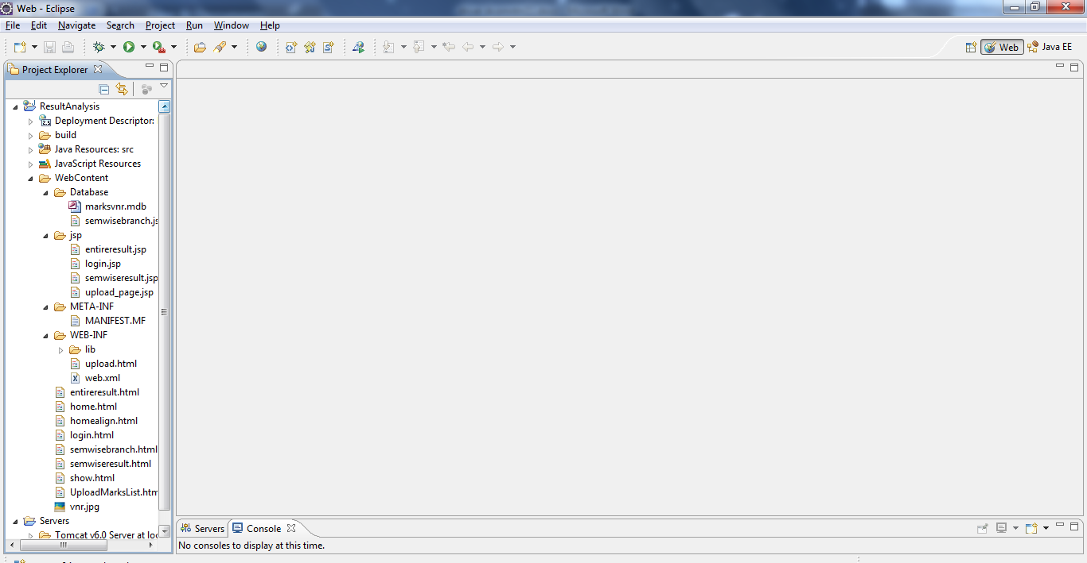

FIG 5.1:Eclipse IDE

5.2JAVA/J2EE
JDBC is a Java-based data access technology (Java Standard Edition platform) from Sun Microsystems, Inc... It is not an acronym as it is unofficially referred to as Java Database Connectivity. This technology is an API for the Java programming language that defines how a client may access a database. It provides methods for querying and updating data in a database. JDBC is oriented towards relational databases. A JDBC-to-ODBC bridge enables connections to any ODBC-accessible data source in the JVM host environment.

5.2.1 FUNCTIONALITY

JDBC allows multiple implementations to exist and be used by the same application. The API provides a mechanism for dynamically loading the correct Java packages and registering them with the JDBC Driver Manager. The Driver Manager is used as a connection factory for creating JDBC connections.

JDBC connections support creating and executing statements. These may be update statements such as SQL's CREATE, INSERT, UPDATE and DELETE, or they may be query statements such as SELECT. Additionally, stored procedures may be invoked through a JDBC connection. JDBC represents statements using one of the following classes:
- Statement – the statement is sent to the database server each and every time.
- PreparedStatement – the statement is cached and then the execution path is pre determined on the database server allowing it to be executed multiple times in an efficient manner.
- CallableStatement – used for executing stored procedures on the database.
Update statements such as INSERT, UPDATE and DELETE return an update count that indicates how many rows were affected in the database. These statements do not return any other information.

Query statements return a JDBC row result set. The row result set is used to walk over the result set. Individual columns in a row are retrieved either by name or by column number. There may be any number of rows in the result set. The row result set has metadata that describes the names of the columns and their types.

There is an extension to the basic JDBC API in the javax.sql.

JDBC connections are often managed via a connection pool rather than obtained directly from the driver. Examples of connection pools include BoneCP, C3P0 and DBCP

5.2.2 JDBC DRIVERS

JDBC drivers are client-side adapters (installed on the client machine, not on the server) that convert requests from Java programs to a protocol that the DBMS can understand.

Types
There are commercial and free drivers available for most relational database servers. These drivers fall into one of the following types:
- Type 1 that calls native code of the locally available ODBC driver.
- Type 2 that calls database vendor native library on a client side. This code then talks to database over network.
- Type 3, the pure-java driver that talks with the server-side middleware that then talks to database.
- Type 4, the pure-java driver that uses database native protocol.
There is also a type called internal JDBC driver, driver embedded with JRE in Java-enabled SQL databases. It's used for Java stored procedures. This does not belong to the above classification, although it would likely be either a type 2 or type 4 driver (depending on whether the database itself is implemented in Java or not). An example of this is the KPRB driver supplied with Oracle RDBMS. "jdbc:default:connection" is a relatively standard way of referring making such a connection (at least Oracle and Apache Derby support it). The distinction here is that the JDBC client is actually running as part of the database being accessed, so access can be made directly rather than through network protocols.

5.3 MICROSOFT ACCESS

A database management, or DBMS, gives the user access to their data and helps them transform the data into information. Such database management systems include dBase, paradox, IMS, Microsoft Access and Microsoft Access. These systems allow users to create, update and extract information from their database.
A database is a structured collection of data. Data refers to the characteristics of people, things and events. Microsoft Access stores each data item in its own fields. In Microsoft Access, the fields relating to a particular person, thing or event are bundled together to form a single complete unit of data, called a record (it can also be referred to as raw or an occurrence). Each record is made up of a number of fields. No two fields in a record can have the same field name.
During an Microsoft Access Database design project, the analysis of your business needs identifies all the fields or attributes of interest. If your business needs change over time, you define any additional fields or change the definition of existing fields.

5.3.1 MICROSOFT ACCESS TABLES
Microsoft Access stores records relating to each other in a table. Different tables are created for the various groups of information. Related tables are grouped together to form a database.

5.3.1.1 PRIMARY KEY
Every table in Microsoft Access has a field or a combination of fields that uniquely identifies each record in the table. The Unique identifier is called the Primary Key, or simply the Key. The primary key provides the means to distinguish one record from all other in a table. It allows the user and the database system to identify, locate and refer to one particular record in the database.

5.3.1.2 RELATIONAL DATABASE
Sometimes all the information of interest to a business operation can be stored in one table. Microsoft Access makes it very easy to link the data in multiple tables. Matching an employee to the department in which they work is one example. This is what makes Microsoft Access a relational database management system, or RDBMS. It stores data in two or more tables and enables you to define relationships between the table and enables you to define relationships between the tables.

5.3.1.3 FOREIGN KEY
When a field is one table matches the primary key of another field is referred to as a foreign key. A foreign key is a field or a group of fields in one table whose values match those of the primary key of another table.

5.3.1.4 REFERENTIAL INTEGRITY
Not only does Microsoft Access allow you to link multiple tables, it also maintains consistency between them. Ensuring that the data among related tables is correctly matched is referred to as maintaining referential integrity.

5.3.1.5 DATA ABSTRACTION
A major purpose of a database system is to provide users with an abstract view of the data. This system hides certain details of how the data is stored and maintained. Data abstraction is divided into three levels.

Physical level: This is the lowest level of abstraction at which one describes how the data are actually stored.

Conceptual Level: At this level of database abstraction all the attributed and what data are actually stored is described and entries and relationship among them.

View level: This is the highest level of abstraction at which one describes only part of the database.

5.3.2 ADVANTAGES OF RDBMS

- Redundancy can be avoided
- Inconsistency can be eliminated
- Data can be Shared
- Standards can be enforced
- Security restrictions ca be applied
- Integrity can be maintained
- Conflicting requirements can be balanced
- Data independence can be achieved.

5.3.3 DISADVANTAGES OF DBMS
A significant disadvantage of the DBMS system is cost. In addition to the cost of purchasing of developing the software, the hardware has to be upgraded to allow for the extensive programs and the workspace required for their execution and storage. While centralization reduces duplication, the lack of duplication requires that the database be adequately backed up so that in case of failure the data can be recovered.

5.3.4 FEATURES OF MICROSOFT ACCESS (RDBMS)
MICROSOFT ACCESS is one of the leading database management systems (DBMS) because it is the only Database that meets the uncompromising requirements of today’s most demanding information systems. From complex decision support systems (DSS) to the most rigorous online transaction processing (OLTP) application, even application that require simultaneous DSS and OLTP access to the same critical data, Microsoft Access leads the industry in both performance and capability

MICROSOFT ACCESS is a truly portable, distributed, and open DBMS that delivers unmatched performance, continuous operation and support for every database.
MICROSOFT ACCESS RDBMS is high performance fault tolerant DBMS which is specially designed for online transactions processing and for handling large database application.

MICROSOFT ACCESS with transactions processing option offers two features which contribute to very high level of transaction processing throughput, which are

- The row level lock manager

5.3.5 ENTERPRISE WIDE DATA SHARING
The unrivaled portability and connectivity of the MICROSOFT ACCESS DBMS enables all the systems in the organization to be linked into a singular, integrated computing resource.

5.3.6 PORTABILITY
MICROSOFT ACCESS is fully portable to more than 80 distinct hardware and operating systems platforms, including UNIX, MSDOS, OS/2, Macintosh and dozens of proprietary platforms. This portability gives complete freedom to choose the database sever platform that meets the system requirements.

5.3.7 OPEN SYSTEMS
MICROSOFT ACCESS offers a leading implementation of industry –standard SQL. Microsoft Access’s open architecture integrates MICROSOFT ACCESS and non –MICROSOFT ACCESS DBMS with industries most comprehensive collection of tools, application, and third party software products Microsoft Access’s Open architecture provides transparent access to data from other relational database and even non-relational database.

5.3.8 DISTRIBUTED DATA SHARING
Microsoft Access’s networking and distributed database capabilities to access data stored on remote server with the same ease as if the information was stored on a single local computer. A single SQL statement can access data at multiple sites. You can store data where system requirements such as performance, security or availability dictate.

5.3.9 UNMATCHED PERFORMANCE
The most advanced architecture in the industry allows the MICROSOFT ACCESS DBMS to deliver unmatched performance.

5.3.10 SOPHISTICATED CONCURRENCY CONTROL
Real World applications demand access to critical data. With most database Systems application becomes “contention bound” – which performance is limited not by the CPU power or by disk I/O, but user waiting on one another for data access . Microsoft Access employs full, unrestricted row-level locking and contention free queries to minimize and in many cases entirely eliminates contention wait times.

5.3.11 NO I/O BOTTLENECKS
Microsoft Access’s fast commit groups commit and deferred write technologies dramatically reduce disk I/O bottlenecks. While some database write whole data block to disk at commit time, Microsoft Access commits transactions with at most sequential log file on disk at commit time, On high throughput systems, one sequential writes typically group commit multiple transactions. Data read by the transaction remains as shared memory so that other transactions may access that data without reading it again from disk. Since fast commits write all data necessary to the recovery to the log file, modified blocks are written back to the database independently of the transaction commit, when written from memory to disk.

6. SYSTEM DESIGN

6. SYSTEM DESIGN

6.1. INTRODUCTION

Software design sits at the technical kernel of the software engineering process and is applied regardless of the development paradigm and area of application. Design is the first step in the development phase for any engineered product or system. The designer’s goal is to produce a model or representation of an entity that will later be built. Beginning, once system requirement have been specified and analyzed, system design is the first of the three technical activities -design, code and test that is required to build and verify software.

The importance can be stated with a single word “Quality”. Design is the place where quality is fostered in software development. Design provides us with representations of software that can assess for quality. Design is the only way that we can accurately translate a customer’s view into a finished software product or system. Software design serves as a foundation for all the software engineering steps that follow. Without a strong design we risk building an unstable system – one that will be difficult to test, one whose quality cannot be assessed until the last stage.

During design, progressive refinement of data structure, program structure, and procedural details are developed reviewed and documented. System design can be viewed from either technical or project management perspective. From the technical point of view, design is comprised of four activities – architectural design, data structure design, interface design and procedural design.

6.2. E – R DIAGRAMS
  - The relation upon the system is structure through a conceptual ER-Diagram, which not only specifics the existential entities but also the standard relations through which the system exists and the cardinalities that are necessary for the system state to continue.
  - The entity Relationship Diagram (ERD) depicts the relationship between the data objects. The ERD is the notation that is used to conduct the date modeling activity the attributes of each data object noted is the ERD can be described resign a data object descriptions.

The set of primary components that are identified by the ERD are
◆ Data object  Relationships
◆ Attributes  Various types of indicators.
The primary purpose of the ERD is to represent data objects and their relationships.

Whenever an attribute of one entity type refers to another entity type, some relationship exists. A relationship type R among n entity types E1, E2,……., En defines a set of associations or a relationship set among entities from these types. In this system we have identified the following relationships.

6.2.1 E-R Diagrams:
UPLOADING: The first diagram gives the relationship between two entities i.e administrator and marks sheet. Here the relationship is uploading marks sheet. Here administrator uploads the marks sheet
into the database.

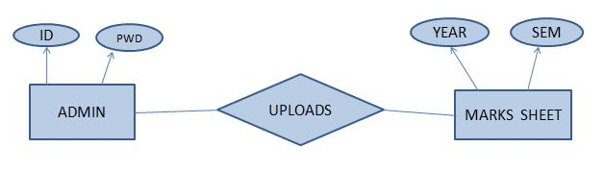

Fig 6.1:E-R diagram(uploading)

VIEWING REPORTS: This diagram gives the relationship between user and reports. Here views the different kinds of reports generated by system.

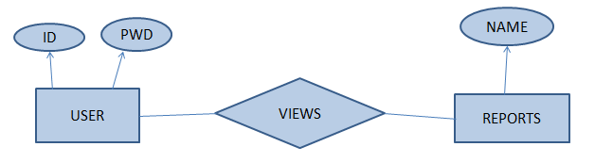

Fig 6.2:E-R diagram for report viewing

6.3. DATA FLOW DIAGRAMS

A data flow diagram is graphical tool used to describe and analyze movement of data through a system. These are the central tool and the basis from which the other components are developed. The transformation of data from input to output, through processed, may be described logically and independently of physical components associated with the system. These are known as the logical data flow diagrams. The physical data flow diagrams show the actual implements and movement of data between people, departments and workstations. A full description of a system actually consists of a set of data flow diagrams. Using two familiar notations Yourdon, Gane and Sarson notation develops the data flow diagrams. Each component in a DFD is labeled with a descriptive name. Process is further identified with a number that will be used for identification purpose. The development of DFD’S is done in several levels. Each process in lower level diagrams can be broken down into a more detailed DFD in the next level. The lop-level diagram is often called context diagram. It consists a single process bit, which plays vital role in studying the current system. The process in the context level diagram is exploded into other process at the first level DFD.
The idea behind the explosion of a process into more process is that understanding at one level of detail is exploded into greater detail at the next level. This is done until further explosion is necessary and an adequate amount of detail is described for analyst to understand the process.
Larry Constantine first developed the DFD as a way of expressing system requirements in a graphical from, this lead to the modular design.
A DFD is also known as a “bubble Chart” has the purpose of clarifying system requirements and identifying major transformations that will become programs in system design. So it is the starting point of the design to the lowest level of detail. A DFD consists of a series of bubbles joined by data flows in the system.

6.3.1 DFD SYMBOLS:
In the DFD, there are four symbols
- A square defines a source(originator) or destination of system data
- An arrow identifies data flow. It is the pipeline through which the information flows
- A circle or a bubble represents a process that transforms incoming data flow into outgoing data flows.
- An open rectangle is a data store, data at rest or a temporary repository of data

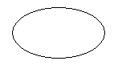 Process that transforms data flow

Source or Destination of data
Data flow

Data Store

6.3.2 CONSTRUCTING A DFD:
Several rules of thumb are used in drawing DFD’S:

- Process should be named and numbered for an easy reference. Each name should be representative of the process.
- The direction of flow is from top to bottom and from left to right. Data traditionally flow from source to the destination although they may flow back to the source. One way to indicate this is to draw long flow line back to a source. An alternative way is to repeat the source symbol as a destination. Since it is used more than once in the DFD it is marked with a short diagonal.
- When a process is exploded into lower level details, they are numbered.
- The names of data stores and destinations are written in capital letters. Process and dataflow names have the first letter of each work capitalized

A DFD typically shows the minimum contents of data store. Each data store should contain all the data elements that flow in and out.
Questionnaires should contain all the data elements that flow in and out. Missing interfaces redundancies and like is then accounted for often through interviews.

6.3.3 SAILENT FEATURES OF DFD’S
- The DFD shows flow of data, not of control loops and decision are controlled considerations do not appear on a DFD.
- The DFD does not indicate the time factor involved in any process whether the dataflow take place daily, weekly, monthly or yearly.
- The sequence of events is not brought out on the DFD.

6.3.4 TYPES OF DATA FLOW DIAGRAMS
- Current Physical
- Current Logical
- New Logical
- New Physical

6.3.4.1 CURRENT PHYSICAL:
In Current Physical DFD process label include the name of people or their positions or the names of computer systems that might provide some of the overall system-processing label includes an identification of the technology used to process the data. Similarly data flows and data stores are often labels with the names of the actual physical media on which data are stored such as file folders, computer files, business forms or computer tapes.

6.3.4.2 CURRENT LOGICAL:
The physical aspects at the system are removed as mush as possible so that the current system is reduced to its essence to the data and the processors those transform them regardless of actual physical form.

6.3.4.3 NEW LOGICAL:
This is exactly like a current logical model if the user were completely happy with he user were completely happy with the functionality of the current system but had problems with how it was implemented typically through the new logical model will differ from current logical model while having additional functions, absolute function removal and inefficient flows recognized.

6.3.4.4 NEW PHYSICAL:
The new physical represents only the physical implementation of the new system.
Context Level Data Flow Diagram for Result Analysis System:

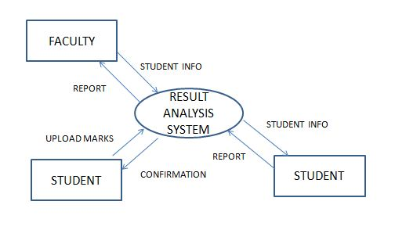

Fig 6.3:data flow diagram for result analysis

Data Flow Diagrams:
Level-1 DFD:
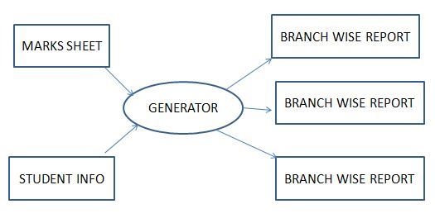

Fig 6.4: Data flow diagram for generating reports

Level 2 DFD:

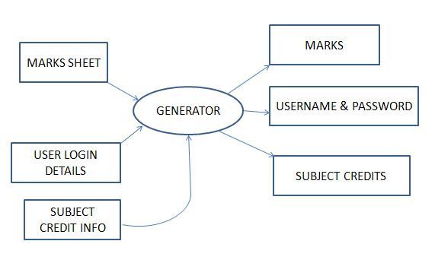

Fig 6.5: data flow diagram for login details

6.4. UML DIAGRAMS

In the field of Software Engineering, the Unified Modeling Language(UML) is a standard visual specification language for object modeling. UML is a general purpose modeling language that includes a graphical notation used to create an abstract model of a system referred to as UML model.

TYPES OF UML DIAGRAMS:

- Class Diagrams
- Object Diagrams
- Use Case Diagrams
- Sequence Diagrams
- Collaboration Diagrams
- Start Chart Diagrams
- Activity Diagrams
- Component Diagrams
- Deployment Diagrams

ADMINISTRATOR MODULE:

Administrator here is the person who is responsible for managing the login details and redirects different users logging in, to their respective interfaces based on their login type.

USE CASE DIAGRAM :

Use case diagram gives the information about set of actors and functions associated with each actor. Here in our use case diagram, we have two actors. They are user and validating system and student and faculty are generalized into user. Each actor has different functions.

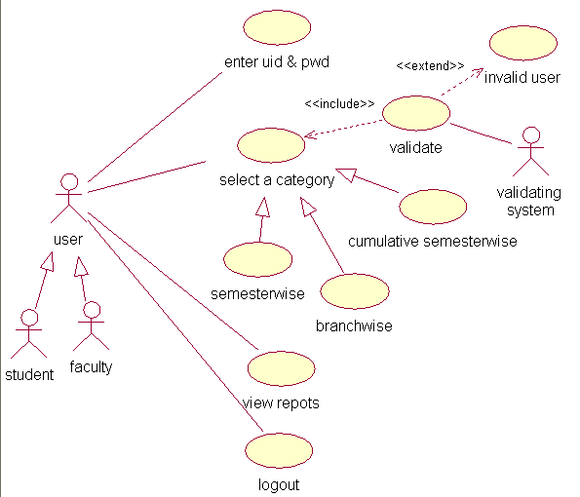

Fig 6.6: Use case diagram

CLASS DIAGRAM:

Class diagram gives the information about set of classes, functions of each class, attributes of each class and relationship among classes. Here in this diagram we have three classes, they are user, administrator and database. We have association relationship between administrator and database, user and database.
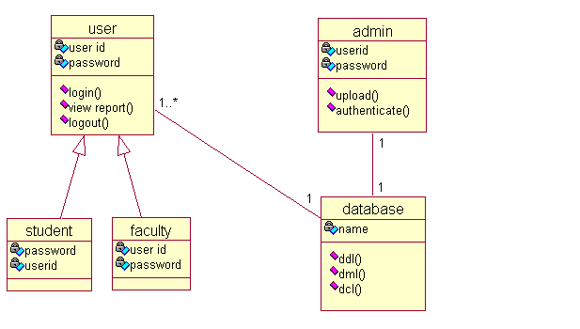

Fig 6.7: class diagram

SEQUENCE DIAGRAM:

Sequence diagram shows the flow of messages among objects in sequence order. In the below diagram we have four objects, they are user, system, database and admin. The first message is uploading the marks into database by administrator and the sequence of messages continues till the lifetime of object ends.

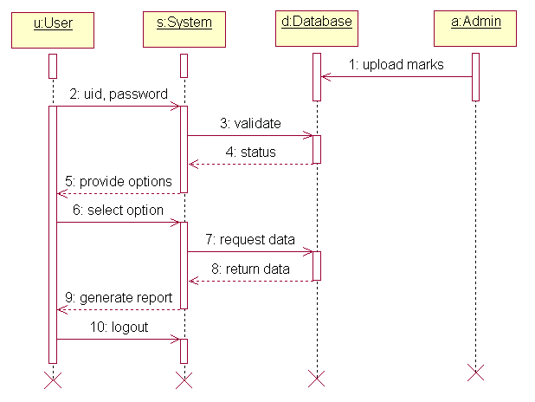

SEQUENCE DIAGRAM:

Fig 6.8: Sequence diagram

7. OUTPUT SCREENS

7. OUTPUT SCREENS

LOGIN SCREEN:

This login page has the fields login id, password and user type. User has to enter those details in order to enter into this application.

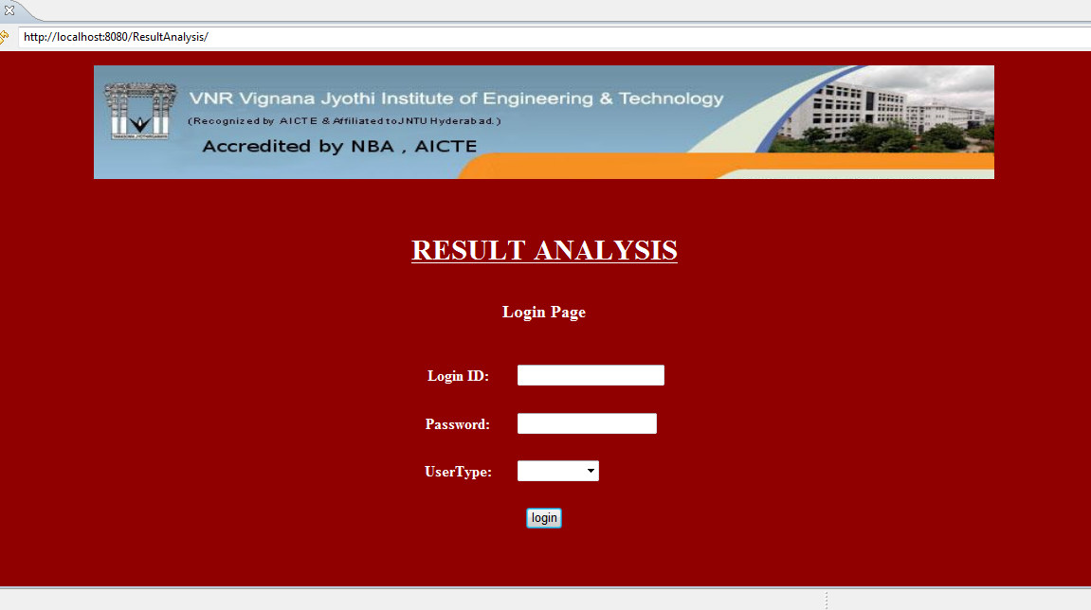

STUDENTS INTERFACE:

Fig 7.1: Login screen shot

HOME SCREEN:

This page will appear when you log in to the application using id and password. This page contains different links to view the different reports.

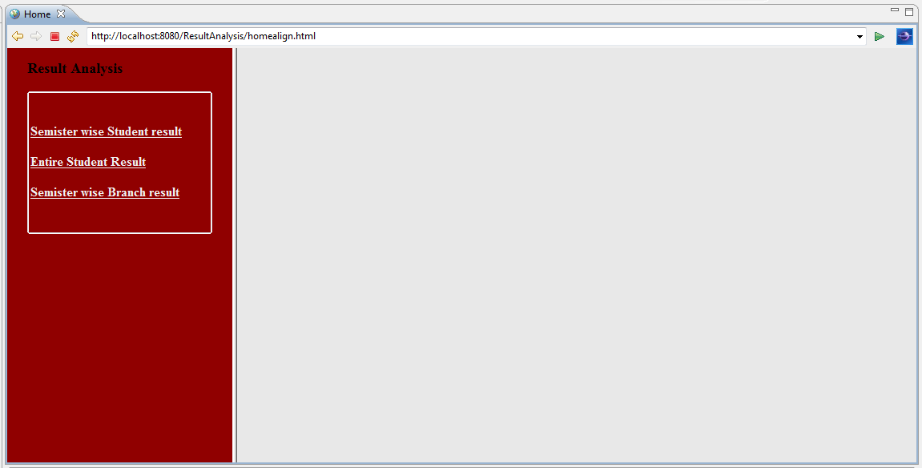

Fig 7.2: Home page

SEMISTER WISE STUDENT RESULT ANALYSIS:

This page contains fields that are used to view the report of student in semester wise.
User has to enter all the three fields and click on submit to view the report of student.

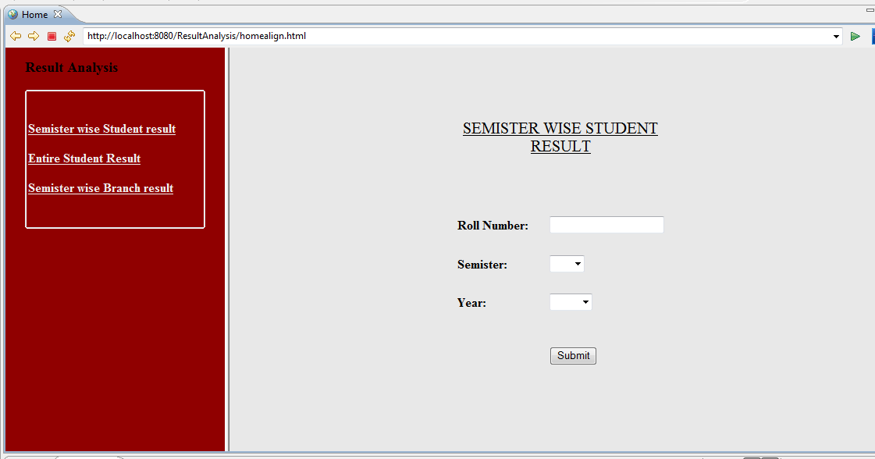

Fig 7.3: semester wise analysis

CUMULATIVE SEMESTER ANALYSIS:

This page contains roll number field, user has to enter the roll number of student in order to view the report containing cumulative semester result.

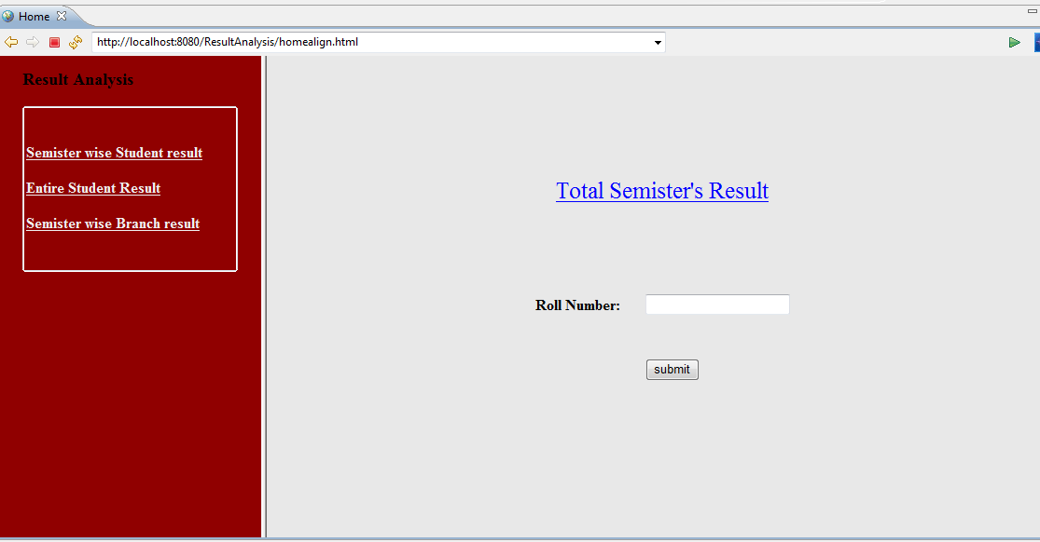

Fig 7.4: Cumulative semester analysis

SEMESTER WISE BRANCH RESULT:

This page has three fields, they are department, semester and year. User has to enter all those fields in order view the report that contains performance of students in each and every subject.

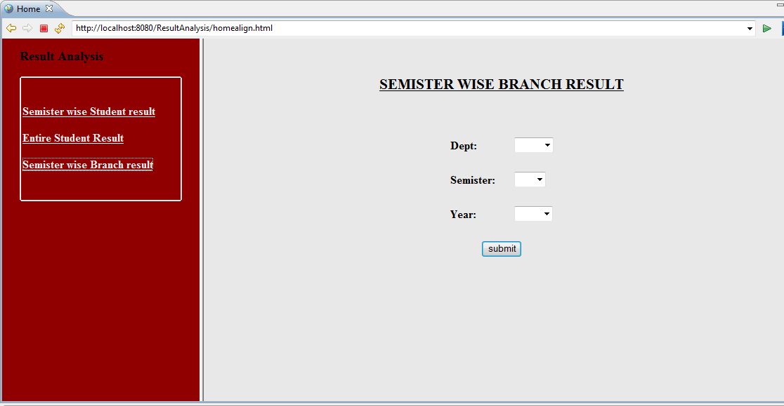

Fig 7.5:Branch wise analysis

STUDENT REPORT PER SEMISTER:

This report gives the information about performance of student in each subject and it calculates the SGPA for that particular semester.

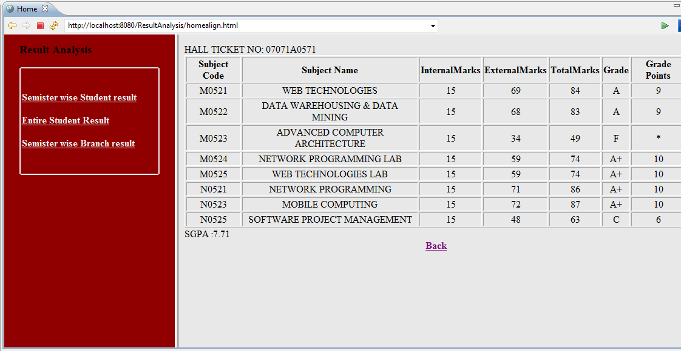

Fig 7.6: Semester wise report

STUDENT REPORT FOR CUMULATIVE SEMESTER:

This report contains SGPA for each semester and CGPA for cumulative semester. This report is used to analyze the performance of student up to the current semester.

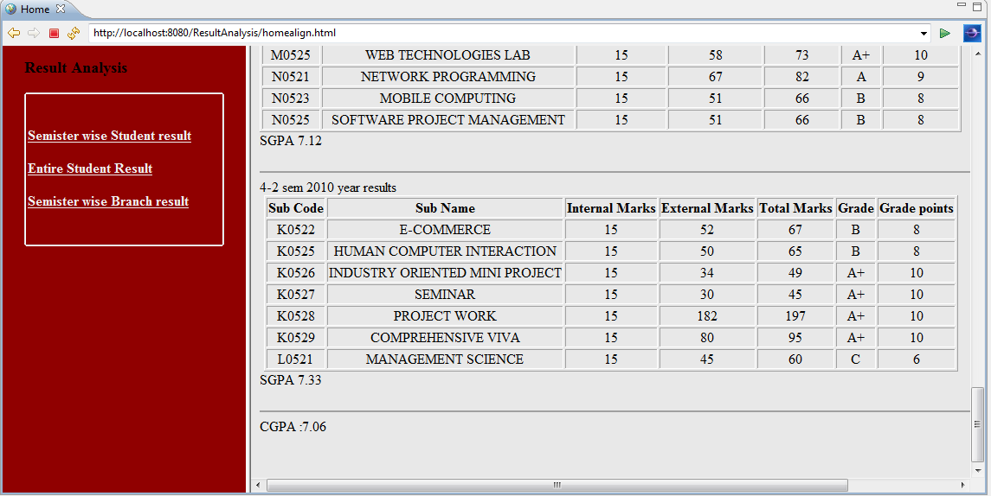

Fig 7.7: Cumulative semester report

ADMIN UPLOADING SCREEN:

This page is used to upload the marks of students into the database. User has to browse the file, then select excel sheet and has to click on upload button.

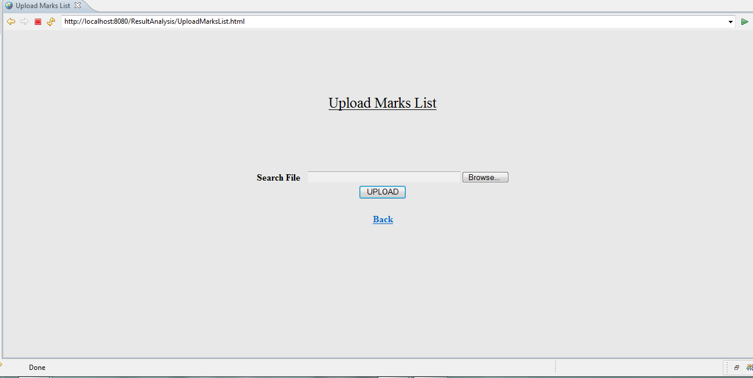

Fig 7.8: uploading marks into database

8. SYSTEM TESTING

8. SYSTEM TESTING

8.1 INTRODUCTION TO TESTING

Testing is a process, which reveals errors in the program. It is the major quality measure employed during software development. During testing, the program is executed with a set of test cases and the output of the program for the test cases is evaluated to determine if the program is performing as it is expected to perform.

8.2 TESTING STRATEGIES
In order to make sure that the system does not have errors, the different levels of testing strategies that are applied at differing phases of software development are:
8.2.1 Unit Testing:
Unit Testing is done on individual modules as they are completed and become executable. It is confined only to the designer's requirements. Each module can be tested using the following two Strategies:
8.2.1.1 Black Box Testing:
In this strategy some test cases are generated as input conditions that fully execute all functional requirements for the program. This testing has been uses to find errors in the following categories:
- Incorrect or missing functions
- Interface errors
- Errors in data structure or external database access
- Performance errors
- Initialization and termination errors.
In this testing only the output is checked for correctness. The logical flow of the data is not checked.

8.2.1.2 White Box testing :
In this the test cases are generated on the logic of each module by drawing flow graphs of that module and logical decisions are tested on all the cases. It has been uses to generate the test cases in the following cases:
- Guarantee that all independent paths have been Executed.
- Execute all logical decisions on their true and false Sides.
- Execute all loops at their boundaries and within their operational bounds
- Execute internal data structures to ensure their validity.

8.2.2 Integrating Testing:
Integration testing ensures that software and subsystems work together a whole. It tests the interface of all the modules to make sure that the modules behave properly when integrated together.
8.2.3 System Testing:
Involves in-house testing of the entire system before delivery to the user. It's aim is to satisfy the user the system meets all requirements of the client's specifications.

8.2.4 Acceptance Testing:
It is a pre-delivery testing in which entire system is tested at client's site to find errors.
8.2.5 Test Approach:
Testing can be done in two ways:
- Bottom up approach
- Top down approach
8.2.5.1 Bottom up Approach:
Testing can be performed starting from smallest and lowest level modules and proceeding one at a time. For each module in bottom up testing a short program executes the module and provides the needed data so that the module is asked to perform the way it will when embedded with in the larger system. When bottom level modules are tested attention turns to those on the next level that use the lower level ones they are tested individually and then linked with the previously examined lower level modules.
8.2.5.2 Top down approach:
This type of testing starts from upper level modules. Since the detailed activities usually performed in the lower level routines are not provided stubs are written. A stub is a module shell called by upper level module and that when reached properly will return a message to the calling module indicating that proper interaction occurred. No attempt is made to verify the correctness of the lower level module.

8.2.6 Validation:
The system has been tested and implemented successfully and thus ensured that all the requirements as listed in the software requirements specification are completely fulfilled. In case of erroneous input, corresponding error messages are displayed.

8.3: Test cases:
Test cases | Inputs | Actual output | Obtained output | Description
Successful login | User id, password | success | success | Test passed. User logged into system
Unsuccessful login | Either user id or password. | failed | failed | Test passed. User not logged in.
Successful report generation | Roll no, year, branch, semester | success | success | Test passed,  generated report.
Unsuccessful report generation  Successful uploading  Unsuccessful uploading | Either roll no, year, branch, semester  .csv files  .csv files | failed  success  failed | failed  success  failed | Test passed, report not generated  Test passed, marks sheet uploaded.  Test passed, marks sheet not uploaded.
FIG 8.1: TEST CASES

9. System Security

9. System Security

9.1. Introduction
The protection of computer based resources that includes hardware, software, data, procedures and people against unauthorized use or natural
Disaster is known as System Security.

System Security can be divided into four related issues:
- Security
- Integrity
- Privacy
- Confidentiality

9.1.1 SYSTEM SECURITY refers to the technical innovations and procedures applied to the hardware and operation systems to protect against deliberate or accidental damage from a defined threat.

9.1.2 DATA SECURITY is the protection of data from loss, disclosure, modification and destruction.

9.1.3 SYSTEM INTEGRITY refers to the power functioning of hardware and programs, appropriate physical security and safety against external threats such as eavesdropping and wiretapping.

9.1.4 PRIVACY defines the rights of the user or organizations to determine what information they are willing to share with or accept from others and how the organization can be protected against unwelcome, unfair or excessive dissemination of information about it.

9.1.5 CONFIDENTIALITY is a special status given to sensitive information in a database to minimize the possible invasion of privacy. It is an attribute of information that characterizes its need for protection.

9.2. SECURITY IN SOFTWARE

System security refers to various validations on data in form of checks and controls to avoid the system from failing. It is always important to ensure that only valid data is entered and only valid operations are performed on the system. The system employees two types of checks and controls:
9.2.1 CLIENT SIDE VALIDATION
Various client side validations are used to ensure on the client side that only valid data is entered. Client side validation saves server time and load to handle invalid data. Some checks imposed are:
- VBScript in used to ensure those required fields are filled with suitable data only. Maximum lengths of the fields of the forms are appropriately defined.
- Forms cannot be submitted without filling up the mandatory data so that manual mistakes of submitting empty fields that are mandatory can be sorted out at the client side to save the server time and load.
- Tab-indexes are set according to the need and taking into account the ease of user while working with the system.

9.2.2 SERVER SIDE VALIDATION
Some checks cannot be applied at client side. Server side checks are necessary to save the system from failing and intimating the user that some invalid operation has been performed or the performed operation is restricted. Some of the server side checks imposed is:
- Server side constraint has been imposed to check for the validity of primary key and foreign key. A primary key value cannot be duplicated. Any attempt to duplicate the primary value results into a message intimating the user about those values through the forms using foreign key can be updated only of the existing foreign key values.
- User is intimating through appropriate messages about the successful operations or exceptions occurring at server side.
- Various Access Control Mechanisms have been built so that one user may not agitate upon another. Access permissions to various types of users are controlled according to the organizational structure. Only permitted users can log on to the system and can have access according to their category. User- name, passwords and permissions are controlled o the server side.
- Using server side validation, constraints on several restricted operations are imposed.

10. CONCLUSION

10. CONCLUSION

It has been a great pleasure for me to work on this exciting and challenging project. This project proved good for me as it provided practical knowledge of not only programming in JSP web based application and know some extent Windows Application and Microsoft Access, but also about all handling procedure related with “Result analysis system”. It also provides knowledge about the latest technology used in developing web enabled application and client server technology that will be great demand in future. This will provide better opportunities and guidance in future in developing projects independently.

BENEFITS:
This system will generate reports :

- Efficient
- Flexible
- Less time consuming

11. FUTURE IMPROVEMENT

11. FUTURE IMPROVEMENT

- This application can support vast number of students and branches.
- As the technology emerges, it is possible to upgrade the system and can be adaptable to desired environment.
- Because it is based on object-oriented design, any further changes can be easily adaptable.
- Based on the future security issues, security can be improved using emerging technologies.
- Emails can be sent to the respective lecturers and class students.

12. BIBLIOGRAPHY

12. BIBLIOGRAPHY

Web References:
- http://msdn2.microsoft.com/en-us/library
- http://www.w3.org/2002/ws/
- http://en.wikipedia.org/wiki/Web_services
- http://www.123aspx.com/
- http://collegescheduling.com/Configurable_Parameters.html
- http://www.tutorialspoint.com/jdbc/jdbc-create-tables.html
- http://msdn.microsoft.com/library/default.asp?url=/library/en-us/dnasp/html/asptutorial.asp
- http://www.functionx.com/sqlserver/
- Java complete reference by Herbert shield
- JSP by orielly publcations

